Experiment Details

|  |  |
| --- | --- |
| Department Name | Department of Electronics & Telecommunication |
| Class | T.Y.B.Tech |
| Semester | V |
| Subject Name | Microcontroller |
| Experiment No. | 01 |
| Experiment Name | Block Transfer and Block Exchange |

Version History

|  |  |  |  |  |
| --- | --- | --- | --- | --- |
| Sr. No. | Version Number | Created By | Approved By | Date |
| 1 | v1.0 | Rani Bhendigeri | Mr. Vikas B.Gundavade | 10/10/2020 |
|  |  |  |  |  |

AIM:

*Perform data transfer operation using assembly language.*

THEORY:

**BLOCK TRANSFER OPERATION : Internal to Internal memory**

**ALGORITHM:**

Step 1: Start

Step 2: Initialize counter to number of bytes

Step 3: Initialize two memory locations

Step 4: Move the byte from source to accumulator

Step 5: Move the data of accumulator to destination

Step 6: Increment the memory locations

Step 7: Decrement counter

Step 8: Go to step 4 till counter becomes zero

Step 9: End

***FLOWCHART***

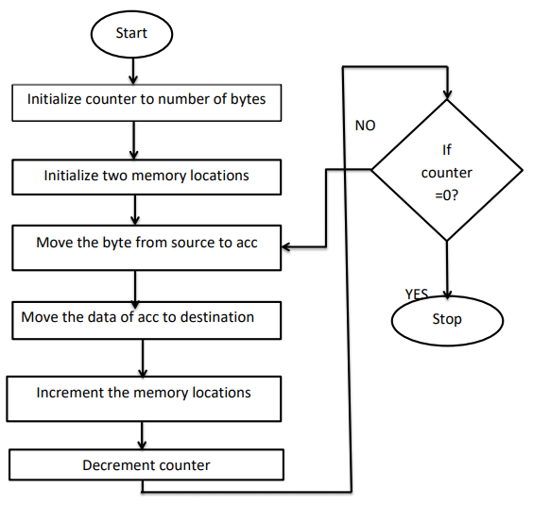

PRE TEST:

1. The register that may be used as an operand register is  
a) Accumulator  
b) B register  
c) Data register  
d) Accumulator and B register

Answer: d

2. The registers that contain the status information is  
a) control registers  
b) instruction registers  
c) program status word  
d) all of the mentioned

Answer: c

3. Program counter stores what?  
a) Address of before instruction  
b) Address of the next instruction  
c) Data of the before execution to be executed  
d) Data of the execution instruction

Answer: b

4. The disadvantage of CISC design processors is  
a) low burden on compiler developers  
b) wide availability of existing software  
c) complex in nature  
d) none

Answer: c

5. The RISC architecture is preferred to CISC because RISC architecture has  
a) simplicity  
b) efficiency  
c) high speed  
d) all of the mentioned

Answer: d

PROCEDURE:

Click on the button “START”. It takes to simulation screen. "START" button will changed to "Next" button, Program Code will appear in Code block and Variable names "Memory", "Address", "Data" with initialzed value to zero in right block will appear. Click on "next" button for executing step by step instruction, user will get comments with every instruction executed. Input box will appear when instruction for input is executed, and "Next" button will convert to "SUBMIT" button. After submitting input, SUBMIT turns to Next and program will execute step by step showing changes of the values in Variable names

POST TEST:

1. The number of 8-bit registers that a register bank contain is  
a) 2  
b) 4  
c) 6  
d) 8

Answer: c

2. Which of the following is not an addressing mode of 8051?  
a) register instructions  
b) register specific instructions  
c) indexed addressing  
d) none

Answer: d

3. The symbol, ‘addr 16’ represents the 16-bit address which is used by the instructions to specify the  
a) destination address of CALL  
b) source address of JUMP  
c) destination address of call or jump  
d) source address of call or jump

Answer: c

4. The storage of addresses that can be directly accessed is  
a) external data RAM  
b) internal data ROM  
c) internal data RAM and SFRS  
d) external data ROM and SFRS

Answer: c

5. The addressing mode, in which the instructions has no source and destination operands is  
a) register instructions  
b) register specific instructions  
c) direct addressing  
d) indirect addressing

Answer: b

REFERENCES:

1. “The 8051 Microcontroller Architecture, Programming & Applications”, Kenneth J. Ayala 2e, Thomson Learning 2005.

2. “The 8051 Microcontroller and Embedded Systems – using assembly and C”, Muhammad Ali Mazidi and Janice Gillespie Mazidi and Rollin D. McKinlay; PHI, 2006